Quiz: Rotation
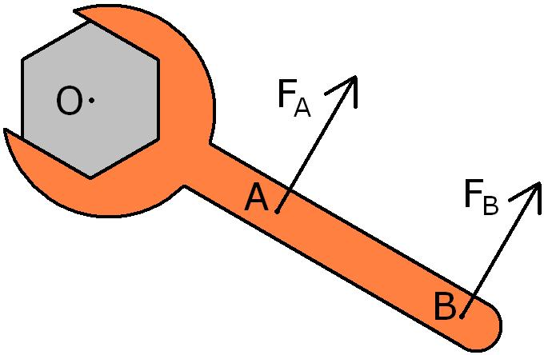

- You are attempting to loosen a bolt from your car by putting a force on a wrench, as shown in the picture. You can choose to put a force on the wrench at point A or at point B. If both the forces are the same magnitude, which force is more effective in loosening the bolt?
  - Force A is more likely to turn the bolt because the force is applied closer to the bolt.
  - Force A is more likely to turn the bolt because F_{A}/r is greater than F_{B}/r.
  - Force B is more likely to turn the bolt because F_{B} has a larger magnitude.
  - Force B is more likely to turn the bolt because it produces a greater torque.
  - Both forces will turn the bolt in the same manner because the magnitude of both forces is the same.

- An alligator can snap its jaws shut in as little as 1.3x10⁻⁴ s. During this time, the alligator's jaws rotate through an angle of 90°. If its jaws start from rest and maintain a constant angular acceleration, what is the angular acceleration of its jaws?
  - 1.065 x 10¹⁰ rad/s²
  - 1.859 x 10⁸ rad/s²
  - 6.23 x 10⁵ rad/s²
  - 1.208 x 10⁴ rad/s²

- A force F acts on a cylinder, causing it to accelerate at a constant rate, α. If a second cylinder had twice the radius, and a force of F/2 acted on the second cylinder, what would its angular acceleration be in terms of α?
  - α/4
  - α/2
  - α
  - 2α

- A speedometer works by detecting angular velocity of your car's wheels and then calculating linear velocity. You decide to replace the 35.56 cm diameter rims (14 inch) on your Toyota Corolla with 50.8 cm (20 inch) rims. You find that your speedometer now displays a speed that is -
  - too low, because the angular velocity has decreased.
  - too high, because the torque generated by the motor is greater.
  - too high, because the radius is now larger.
  - accurate – the size of the rims does not change the speedometer's function.

- Some drag-racing cars are built with the front wheels far ahead of the (rear) drive wheels. The main reason for this is -
  - To reduce air resistance
  - To provide better traction
  - To help keep the front of the car down
  - To make the car more intimidating to the competitors.

- You are preparing to eat spaghetti at an Italian restaurant when the waiter asks if you would like Parmesan-Reggiano cheese grated over the top. You reply yes, but unfortunately, the cheese irritates your nose. You sneeze, causing your meatball to roll (without sliding) off your plate. Which of the following did your sneeze provide to the meatball?
  - Force
  - Torque
  - Rotational Kinetic Energy
  - All of the above

- You are driving on snow when your realize your rear wheels are skidding to the right. To maintain control of your vehicle, driving instructors suggest you should steer to the right in this situation. This is because -
  - Steering to the right puts a torque on your vehicle that counters the rotation.
  - Steering the right decreases the friction on your car, making it slide better.
  - Steering to the right causes your car to have an angular acceleration that increases the rotation of the car.
  - Driving instructors are wrong, and you should steer to the left.

- A student is rotating while sitting with the arms and legs crossed on a spinning stool. What happens to her angular velocity and angular momentum when she extends her arms and legs?
  - Angular Velocity increases, Angular momentum increases.
  - Angular Velocity decreases, Angular momentum increases.
  - Angular Velocity remains constant, Angular momentum decreases.
  - Angular Velocity increases, Angular momentum remains constant..

- One type of slingshot uses a rope that is attached to a rock. The rock is whirled around in a circle until it is launched at a significant speed. Suppose a slingshot has a length of 0.15m, and the rock is launched at 40 m/s after being revolved in five full circles.. Calculate the angular acceleration of the slingshot.
  - 4.244 rad/s²
  - 1131.768 rad/s²
  - 7111 rad/s²
  - It cannot be determined from the given information.

